
Sultan Qaboos University
College of Engineering
Mechatronics Engineering Program
Final Year Project.1 (MCTE5191)

Project Title:
Project Code:

Group Members
11111 – Student
22222 - Student
33333 – Student
44444 – Student

Supervisor(s):
Submitted to: | Dr. Musaab Zarog  (FYP-2 Coordinator)

Supervisor Signature___________________

Dear Students,

This template is only meant as a guide for the report writing. However, changes can be made based on discussions with the projects supervisor. However, the following are compulsory in the report:

Abstract
Acknowledgement
Disclaimer
Table of Contents
List of Figures
List of Tables
Chapter 1: Introduction
Chapter 2: Literature Review
Chapter 3: Conceptual Design and Selection (This is needed for most ME projects)
Conclusion
References

Best Wishes
FYP Coordinator

Abstract

الملخص

Acknowledgement

Disclaimer

All the work done by a team of students from Sultan Qaboos University. This document represents a students’ project and does not necessarily represent the views of MIE Department and the College of Engineering at Sultan Qaboos University. The information provided within this report is not guaranteed to be accurate, nor does Sultan Qaboos University take responsibility for it.

Table of Contents

Abstract III
Acknowledgement V
Disclaimer VI
List of Figures VIII
List of Tables IX
List of Standards X
List of Symbols X
Chapter 1: Introduction 1
1.1 Background 1
1.2 Problem Statement 1
1.3 Project Objectives 1
1.4 Expected Benefits 1
1.5 Motivation 1
1.6 Impact of the Project 1
1.7 Project Outline 1
Chapter 2: Literature Review 2
Chapter 3: Conceptual Design and Selection 3
Chapter 4: Detailed Design 4
Chapter 5: Prototype Fabrication and Experimental Work 5
Chapter 6: Results and Discussion 6
Conclusion 7
References 8
Appendix A 9

List of Figures

Figure 1.1 Sample of project outline 1

List of Tables

List of Standards

List of Symbols

Chapter 1: Introduction

1.1 Background
The necessary background for someone working in the general area of your work to understand. It should not include what is considered a general knowledge in the area. You may have subsections in this section (1.1.1, 1.1.2, .. etc).

1.2 Problem Statement

1.3 Project Objectives

1.4 Expected Benefits

1.5 Motivation

1.6 Impact of the Project

1.7 Project Outline

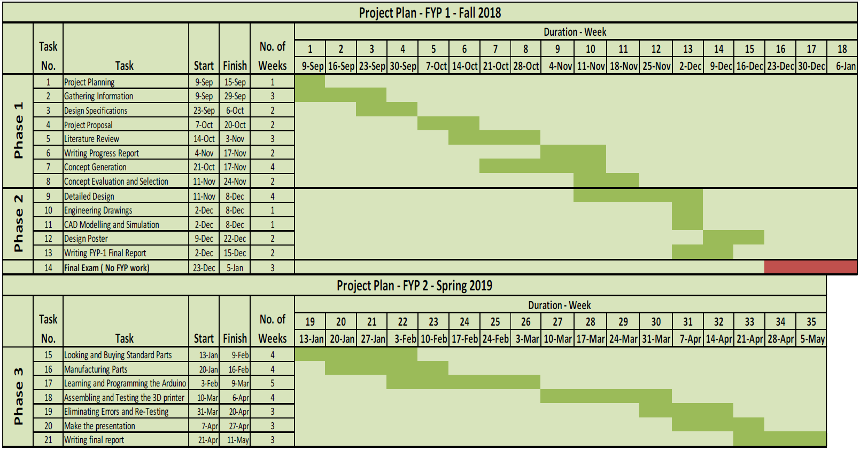

Figure 1.1 Sample of project outline

Chapter 2: Literature Review

A literature review is a search and evaluation of the available literature in your given subject or chosen topic area. It documents the state of the art with respect to the subject or topic you are writing about. The subsections and topics in this chapter should be agreed with the supervisor. You can use software like EndNote or Mendeley to help you organizing the references.

The main tasks of literature review are:

- Demonstrates a familiarity with a body of knowledge and establishes the credibility of your work;
- Summarizes prior research and says how your project is linked to it;
- Integrates and summarizes what is known about a subject;
- Demonstrates that you have learnt from others and that your research is a starting point for new ideas.

Example:

“Functionally graded materials are advantageous over conventional composite materials by having a continuous microstructure and gradual change of properties. This continuity eliminates problems like stress jumps and delamination which are major issues with conventional composite materials. In addition to preserving the advantage of continuous microstructure and gradual change of properties that FG materials offer, FG porous structures offer a significant weight reduction as compared to fully porous structures, and reasonable strength as compared to the precursor foaming material [1, 2]. Functionally graded aluminum foam with linear decreasing density gradient was found to possess excellent performance in energy absorption [3]. A range of linear PVC, crosslinked PVC and PEI foams bonded together to produce a three layer core were fabricated by Zhou and co-authors [4]. It was concluded that the graded structures out-perform a single type foam structure. One important result from their work suggested placing the high density foam core against the top surface skin for an improved perforation resistance. There are many other studies which all support the claim that FG porous structures lead to high strength-to-weight ratio materials.”

Chapter 3: Conceptual Design and Selection

This chapter should contain the design specifications, realistic constraints, physical and functional decomposition of the system (if applicable), conceptual designs and evaluation of each design, which is followed by selection of one of the designs. It is required in this chapter to discuss the following topics either in separate sections or embedded at proper places throughout the chapter:

Design Constraints (time, budget, manufacturing, safety, ethical, .. etc).
Design specifications.
Relevant codes and standards followed.
Local and global impact of the project.

Chapter 4: Detailed Design

This chapter (if applicable at FYP-I in case of projects with multiple phases, otherwise it can be shifted to the report of FYP-II) should contain details of the design and analysis like component design and selection, design analysis (analytical or numerical), cost estimation, .. etc.

Chapter 5: Prototype Fabrication and Experimental Work

If applicable at FYP-I in case of projects with multiple phases, otherwise it can be shifted to the report of FYP-II.

Chapter 6: Results and Discussion

If applicable at FYP-I in case of projects with multiple phases, otherwise it can be shifted to the report of FYP-II.

Conclusion

References

[1] F. Al Jahwari, A. A. W. Anwer, and H. E. Naguib, "Fabrication and microstructural characterization of functionally graded porous acrylonitrile butadiene styrene and the effect of cellular morphology on creep behavior," Journal of Polymer Science Part B: Polymer Physics, vol. 53, pp. 795-803, 2015.
[2] F. A. Jahwari and H. E. Naguib, "Linear viscoelastic modeling and validation of functionally graded heterogeneous porous PLA structures with a C1-continuous plate theory and novel homogenization," presented at the Foams, New Jersey, USA, 2014.
[3] X. Zhang and H. Zhang, "Optimal design of functionally graded foam material under impact loading," International Journal of Mechanical Sciences, vol. 68, pp. 199-211, 2013.
[4] J. Zhou, Z. W. Guan, and W. J. Cantwell, "The impact response of graded foam sandwich structures," Composite Structures, vol. 97, pp. 370-377, 2013.

Appendix A

